**Annual Report of AmazingMartEU2**

**1. Profit Margin of the company State wise.**

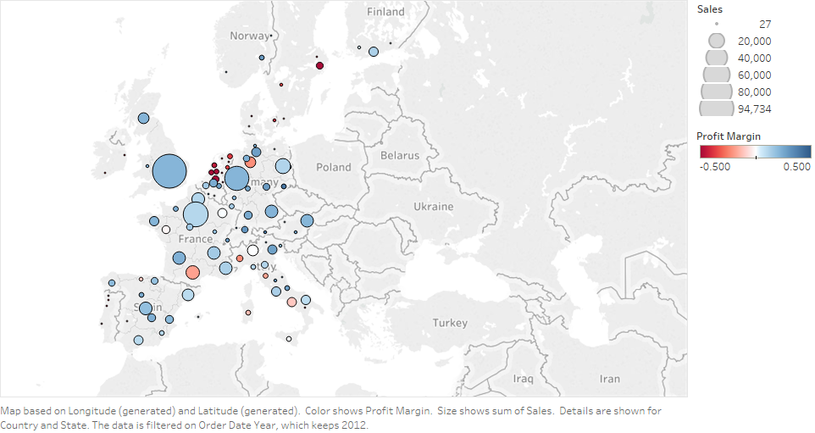

**2. Profit Margin of the company city wise.**

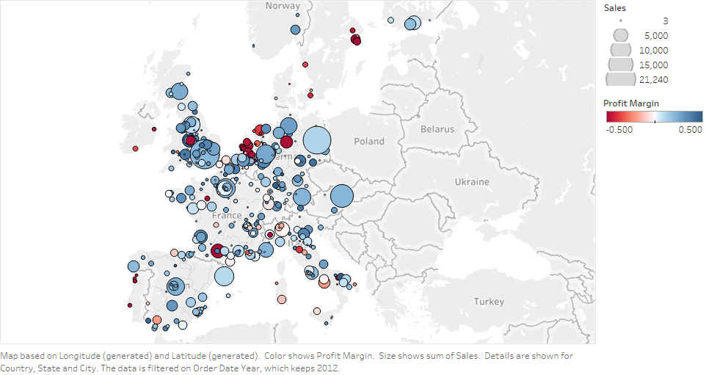

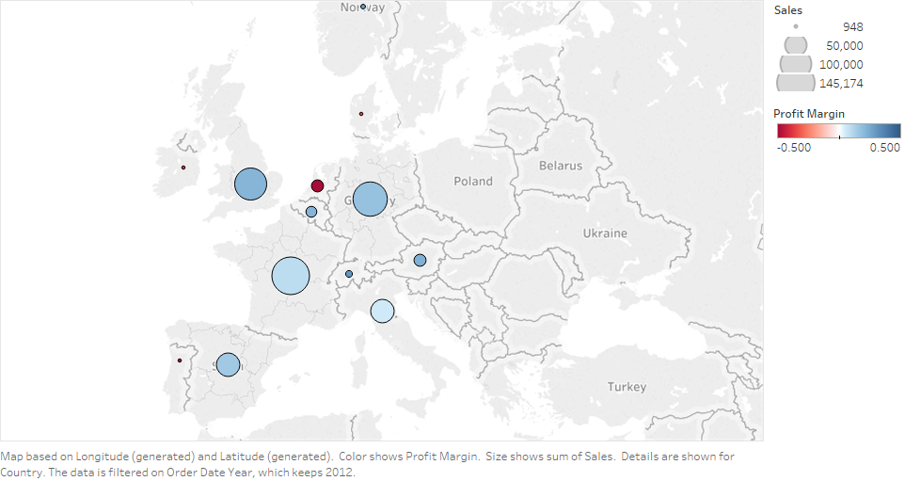**3. Profit Margin of the company city wise.**

**4. Profitability based on customer sales.**

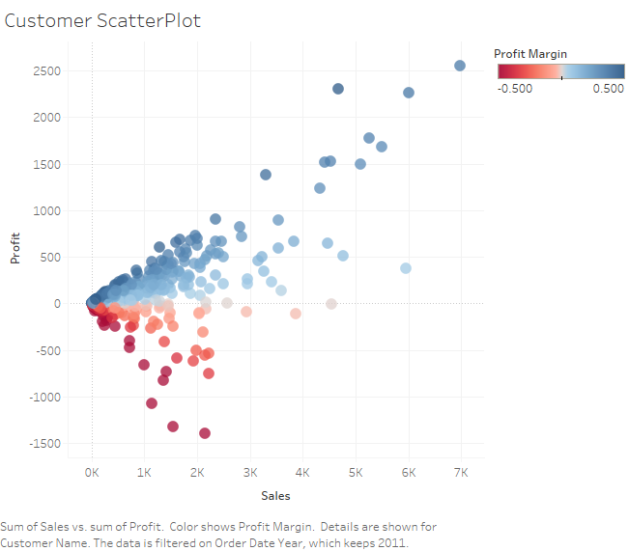

The top profitable customers should be enrolled in loyalty programs so that they can provide more profit.

Those customers are least profitable should be analyzed and checked that what is the reason behind it and should be provided more customer services or maybe they are buying wrong products.